M.V. Lomonosov Moscow State University
N.M. Emanuel Institute of Biochemical Physics RAS
Shemyakin-Ovchinnikov Institute of Bioorganic Chemistry RAS
Federal Research Centre “Fundamentals of Biotechnology” of the RAS
Institute of Physiologically Active Compounds RAS
Institute of Organic and Physical Chemistry A.E. Arbuzov KSC RAS
JSC BioChemMack

12th INTERNATIONAL CONFERENCE
“BIOCATALYSIS.FUNDAMENTALS & APPLICATIONS”
“BIOCATALYSIS-2019”

June, 24-28, 2019, Moscow-St. Petersburg,
Russian Federation

Second Circular

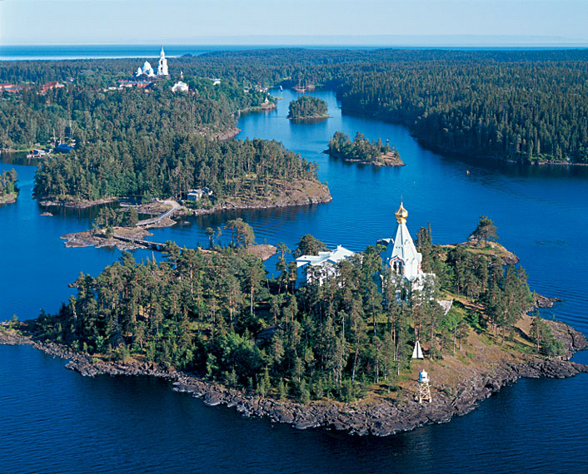
Dear colleagues,

The Lomonosov Moscow State University is planning to convene a traditional biannual 12th International Conference "BIOCATALYSIS-2019" in June, 24–28, 2019.

TENTATIVE SCIENTIFIC PROGRAMME

- Structure, catalytic mechanism and protein engineering of enzymes
- Supercomputer modelling in biocatalysis
- Neuroenzymology
4. Bioinformatics and biocatalysis. Metabolic design
5. Industrial biocatalysis (enzymes, multi enzyme systems and cells). Fine organic synthesis. Design of biotransformation processes
6. Analytical applications of biocatalysis: test systems, biosensors, bioanalytical nanotechnology and biochips. Biocatalysis for chemical and biological safety
7. Biocatalysis in environmental biotechnology
8. Enzyme, ribozymes and proteins as drugs and vaccines
9. Nanomaterials and Nanotechnologies in Life Systems. Safety and Nanomedicine
10. Nanoplasmonics: sensoric and biosensoric applications

PARALLEL SESSION
Co-symposium «Extremophiles and Extremozymes»

Prof. Elizaveta B-Osmolovskaya
Chairman of co-symposium

Form of attendance: oral presentations, poster sessions.

The Organizing Committee is inviting you to attend the International Conference “BIOCATALYSIS-2019”.

Sincerely yours,
Prof. Sergey D. VARFOLOMEYEV
Chairman of the Organizing Committee

All information is available on the Conference website in appropriate sections www.bc2019.org

ADDITIONAL REGISTRATION INSTRUCTIONS

If you plan to go as an accompanying person, we ask you to write in the Note the name of the participant you are traveling with.

Attention!!!

REGISTRATION FEES

Reception of preferential payments is extended from December 1 to
December 31, 2018

Regular registration fee includes: conference materials, welcome party, coffee-breaks, participation in all conference meetings, social program.

Cancellation and refund policy:

Until January 16, 2019 — without penalty fee

From January 17 till March 17, 2019 — penalty fee 30%

From March 18 till April 22, 2019 — penalty fee 70%

After April 23, 2019 — no refund

DEADLINES

Start of online registration | 17.10.2018
The deadline of abstracts submission | 15.03.2019
Early registration fee  Attention!!!  Reception of preferential payments is extended from December 1 to December 31, 2018 | 31.12.2018
The registration for the conference will be completed when all the cabins on the boat will be reserved

Abstracts
The organizing committee of the conference asks the participants to send abstracts to form the conference program. Rules for abstracts are on the conference website:

Title (14 pt, Times New Roman, bold, centered)
First Author¹, Second Author² and Third Author³ (10 pt, Times New Roman, normal, centered)
¹Affiliation
²Affiliation
³Affiliation (10 pt, Times New Roman, Italic, centered)
Keywords: (at most 5 keywords, 12 pt, Times New Roman)

Contributed abstracts must be prepared in English and saved in PDF or MS Word format. The total length is 1 A4 page (12 pt, Times New Roman). Margins: Top and bottom: 1.5 cm, left and right: 2.5 cm. You may use this file as a template.

The submission of abstract can only be through online registration system.

Please, forward all questions on scientific program to the Scientific Secretary of the International Conference Biocatalysis-2019:
Dr. Tatiana Osipova
Phone/Fax:+7-(495)-939-54-17
E-mail: taosip@gmail.com

Your questions on registration fee payment, abstracts submission, hotel, excursions and transfer reservation and payment, visa support you may address to the Technical partner:

Darya Davydova
Project manager
MAKO Congress Management
Phone: +7 (812) 389-30-33
Mob.: +7 (981) 850-05-57
Email: info@bc2019.org
www.makongress.ru
Suite 201-6, 126, Griboedov Canal,
St. Petersburg, Russia, 190068
“MAKO Congress Management”
Mob.: +7 (981) 850-05-57

