Richard G. Pestell, MB, BS, MD, PhD, FACP, FRACP, MBA, Executive Vice President, TJU, Director, Sidney Kimmel Cancer Center, Vice President, Oncology Services, Associate Dean, Cancer Programs, Chairman, Department of Cancer Biology. Dr. Pestell was born in Perth, Western Australia on March 5, 1958. He received his MD (MBBS) from the University of Western Australia and his PhD degree from the University of Melbourne. He undertook post doctoral and clinical training in Hematology/Oncology and Endocrinology. As the single Australian recipient of the Royal Australian College of Physicians’ Winthrop traveling scholar and Neil Hamilton Fairley Scholar (1991-1994), he continued research at Harvard University and served as clinical fellow at Massachusetts General Hospital. For more than 10 years, Dr. Pestell has served as a Director of NCI-designated cancer centers in the USA. Prior to his current position at the Kimmel Cancer Center, Dr. Pestell was Director of the Lombardi Cancer Center, Associate Vice President of the Medical Center at Georgetown University and Board member of the Georgetown University Hospital in Washington, DC.
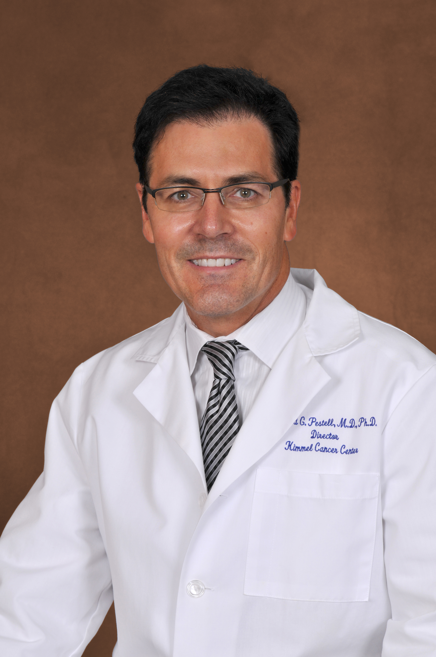
Dr. Pestell has authored more than 400 original publications and book chapters and more than 190 published abstracts. His work is highly cited (~38,200 citations, H-index: 102, i10-index: 343). His papers have been published in prominent peer reviewed journals including Cell, Science, Nature Medicine, Molecular Cell and EMBO J. In March 2002, he was ranked first in the world for increase in total scientific impact in biology and first in the world for biochemistry (ISI). Dr. Pestell is funded as the Principal Investigator of three RO1 grants and Principal Investigator of the Kimmel Cancer Center CCSG grant.
Dr. Pestell has received a number of awards for his scientific discoveries in breast and prostate cancer, including the 2014 Advance Global Australian Award for biotechnology, Harrison Award (highest award of the Australian Endocrine Society), Fellow of the Royal Society of Medicine (UK), Doctor Honoris Causa, (University of Western Australia), elected membership to the American Society of Clinical Investigators, the Irma T. Hirschl Weil Caulier Career Scientist Award, Diane Belfer Faculty Scholar in Cancer Research, the Pfeiffer Award, and elected fellow to the American Association for the Advancement of Science. Dr. Pestell serves as a reviewer for 11 funding agencies and has been an active member of NIH study sections (RO1, SPORES, Cancer Centers, Program projects). Dr. Pestell has been a reviewer for 25 distinct scientific journals (currently an active editorial board member of seven journals) and has served on the external advisory board of six NCI-designated cancer centers.

